Minor Spherical Cap
# Source: AI Source: Provided by: [Data Path: Persons Table -> ID Column: 1, Name_En Column: Motasem Essam] -> From: [ChatGPT] on [7/25/2026]
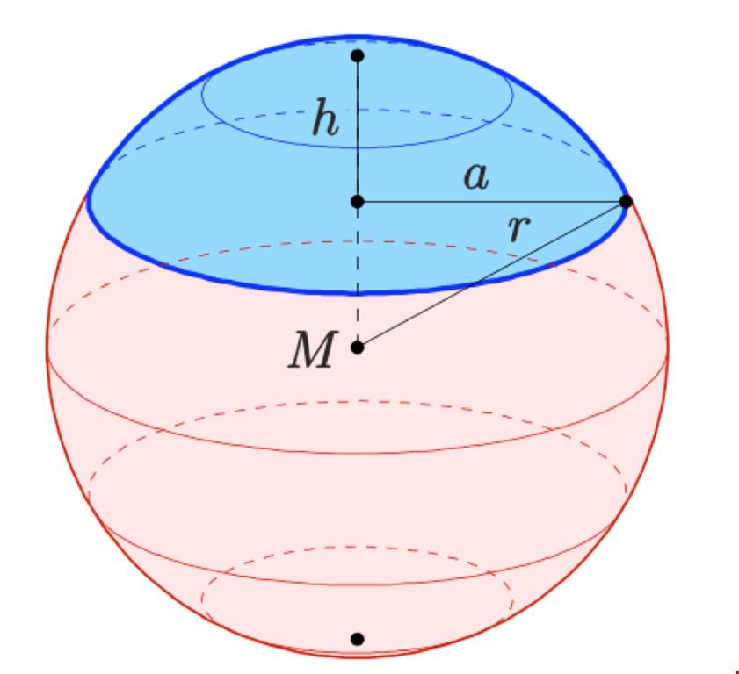
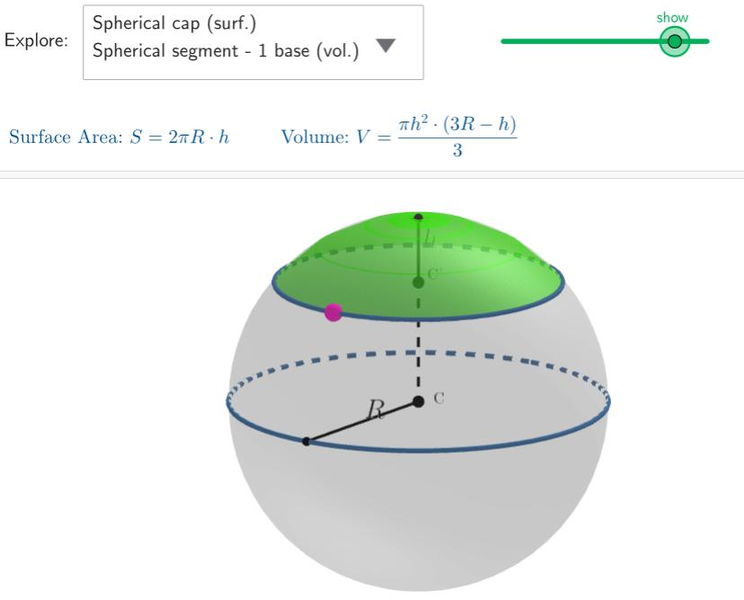
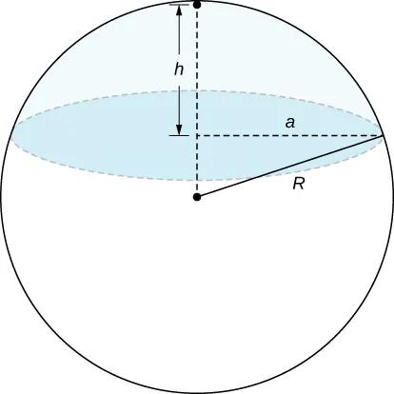

Definition
# Source: AI Source: Provided by: [Data Path: Persons Table -> ID Column: 1, Name_En Column: Motasem Essam] -> From: [ChatGPT] on [7/25/2026]
A minor spherical cap is the smaller portion of a solid sphere separated from the rest of the sphere by a plane. It consists of the curved spherical surface and the solid region enclosed between that surface and the cutting plane.
The plane creates a circular base. For a non-central cut, the sphere is divided into a minor cap and a complementary major cap. The minor spherical cap is the cap with the smaller volume, so its height is less than the sphere’s radius.
A spherical cap is a three-dimensional solid, whereas a spherical segment is the solid portion between two parallel cutting planes.

Simple Definition
# Source: AI Source: Provided by: [Data Path: Persons Table -> ID Column: 1, Name_En Column: Motasem Essam] -> From: [ChatGPT] on [7/25/2026]
A minor spherical cap is the small, dome-like part cut off a sphere by a plane near its surface.
Examples include a shallow dome-shaped portion of a ball or the rounded top of a sphere sliced by a flat plane.

Geometric Structure
# Source: AI Source: Provided by: [Data Path: Persons Table -> ID Column: 1, Name_En Column: Motasem Essam] -> From: [ChatGPT] on [7/25/2026]
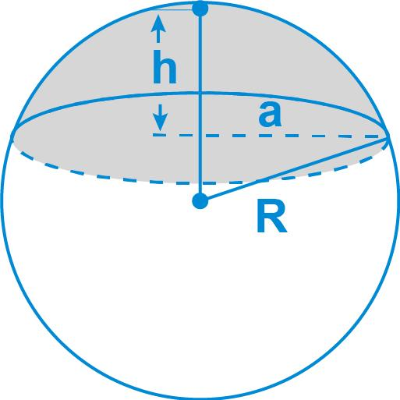
The principal geometric elements are:
- Sphere center $O$: The center of the original sphere.
- Sphere radius $R$: The distance from the center to the spherical surface.
- Cutting plane: The plane that separates the cap from the rest of the sphere.
- Circular base: The disk bounded by the intersection of the plane and the sphere.
- Base radius $a$: The radius of the circular base.
- Cap height $h$: The perpendicular distance from the cutting plane to the highest point of the cap.
- Curved spherical surface: The portion of the sphere’s surface that forms the cap’s dome.
- Cap volume $V$: The three-dimensional space enclosed by the curved surface and the base disk.
For a minor cap, $0<h<R$. The cutting plane lies between the sphere’s center and its nearest surface point.

Mathematical Representation
# Source: AI Source: Provided by: [Data Path: Persons Table -> ID Column: 1, Name_En Column: Motasem Essam] -> From: [ChatGPT] on [7/25/2026]
Assume a sphere centered at the origin with radius $R$, and a horizontal cutting plane at height $z=R-h$.
The sphere equation is
$$x^{2}+y^{2}+z^{2}=R^{2}$$
At the cutting plane, $z=R-h$. Substitution gives
$$x^{2}+y^{2}=R^{2}-{\left(R-h\right)}^{2}$$
Expanding and simplifying:
$$x^{2}+y^{2}=2Rh-h^{2}$$
Therefore, the base radius is
$$\boxed{a=\sqrt{2Rh-h^{2}}}$$
The cap’s volume and surface areas depend on the sphere radius $R$ and cap height $h$.

Important Formulas
# Source: AI Source: Provided by: [Data Path: Persons Table -> ID Column: 1, Name_En Column: Motasem Essam] -> From: [ChatGPT] on [7/25/2026]
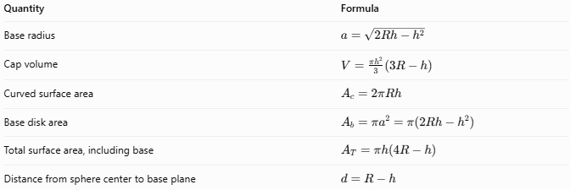
Quantity | Formula
Base radius | $$a=\sqrt{2Rh-h^{2}}$$
Cap volume | $$V=\frac{πh^{2}}{3}\left(3R-h\right)$$
Curved surface area | $$A_{c}=2πRh$$
Base disk area | $$A_{b}=πa^{2}=π\left(2Rh-h^{2}\right)$$
Total surface area, including base | $$A_{T}=πh\left(4R-h\right)$$
Distance from sphere center to base plane | $$d=R-h$$
Note: The curved surface area excludes the flat circular base. The total surface area includes both the curved surface and the base disk.

Worked Example
# Source: AI Source: Provided by: [Data Path: Persons Table -> ID Column: 1, Name_En Column: Motasem Essam] -> From: [ChatGPT] on [7/25/2026]
A sphere has radius $R=10\text{ cm}$. A plane cuts off a minor spherical cap of height $h=3\text{ cm}$. Find its base radius, volume, and total surface area.
Step 1 — Base radius
$$a=\sqrt{2Rh-h^{2}}$$
$$a=\sqrt{2\left(10\right)\left(3\right)-3^{2}}=\sqrt{51}$$
$$\boxed{a≈7.14\text{ cm}}$$
Step 2 — Cap volume
$$V=\frac{πh^{2}}{3}\left(3R-h\right)$$
$$V=\frac{π{\left(3\right)}^{2}}{3}\left(30-3\right)=81π$$
$$\boxed{V≈254.47{\text{ cm}}^{3}}$$
Step 3 — Total surface area
$$A_{T}=πh\left(4R-h\right)$$
$$A_{T}=π\left(3\right)\left(40-3\right)=111π$$
$$\boxed{A_{T}≈348.72{\text{ cm}}^{2}}$$
Conclusion: The minor spherical cap has a base radius of approximately $7.14\text{ cm}$, a volume of $254.47{\text{ cm}}^{3}$, and a total surface area of $348.72{\text{ cm}}^{2}$.

Comparison with Related Solids
# Source: AI Source: Provided by: [Data Path: Persons Table -> ID Column: 1, Name_En Column: Motasem Essam] -> From: [ChatGPT] on [7/25/2026]
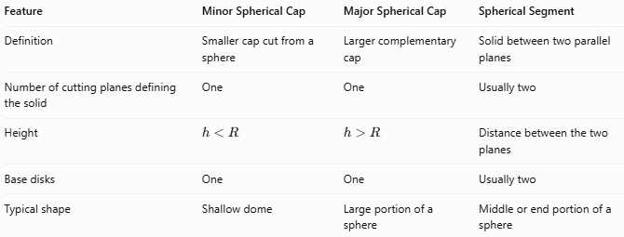
Feature | Minor Spherical Cap | Major Spherical Cap | Spherical Segment
Definition | Smaller cap cut from a sphere | Larger complementary cap | Solid between two parallel planes
Number of cutting planes defining the solid | One | One | Usually two
Height | $$h<R$$ | $$h>R$$ | Distance between the two planes
Base disks | One | One | Usually two
Typical shape | Shallow dome | Large portion of a sphere | Middle or end portion of a sphere
A hemisphere is a special spherical cap with $h=R$. In that case, the cutting plane passes through the sphere’s center.

Applications
# Source: AI Source: Provided by: [Data Path: Persons Table -> ID Column: 1, Name_En Column: Motasem Essam] -> From: [ChatGPT] on [7/25/2026]
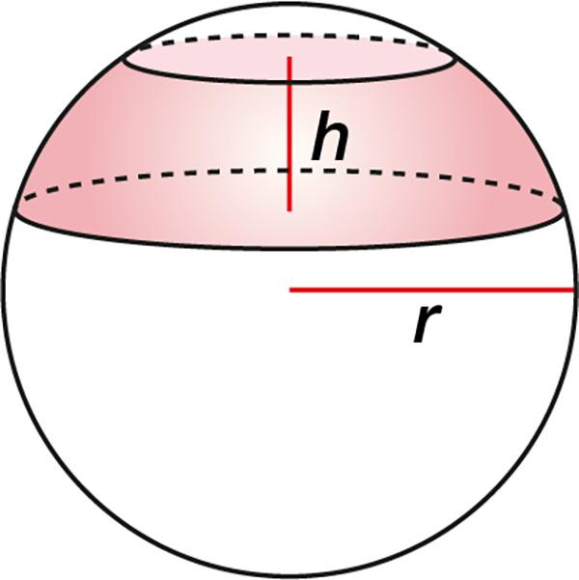
Minor spherical caps appear in:
- Architecture: Shallow domes and rounded roof structures.
- Manufacturing: Rounded components and spherical parts cut to a specified height.
- Engineering: Estimating the material needed for spherical sections.
- Optics: Modeling curved lens or reflector geometries.
- Mathematics: Calculating volumes and areas of sphere sections.

Key Points
# Source: AI Source: Provided by: [Data Path: Persons Table -> ID Column: 1, Name_En Column: Motasem Essam] -> From: [ChatGPT] on [7/25/2026]
- A minor spherical cap is the smaller solid portion cut from a sphere by a plane.
- Its height satisfies $0<h<R$.
- Its base is a circle with radius $a=\sqrt{2Rh-h^{2}}$.
- Its volume is $V=\frac{πh^{2}}{3}\left(3R-h\right)$.
- Its curved surface area is $2πRh$.
- Its total surface area includes the base disk.
- A spherical cap has one flat base, while a spherical segment generally has two.

Conclusion
# Source: AI Source: Provided by: [Data Path: Persons Table -> ID Column: 1, Name_En Column: Motasem Essam] -> From: [ChatGPT] on [7/25/2026]
A minor spherical cap is the smaller dome-shaped solid separated from a sphere by a plane. Its dimensions are determined by the sphere radius and cap height. The main formulas allow its base radius, volume, curved surface area, and total surface area to be calculated accurately.

